Power BI Startup Guide

This outline should help a beginner get started with Power BI, understanding its basic functionalities and how to perform essential tasks.

**Step 1: Add Data to Create a Report**

Power BI allows you to create powerful semantic models and reports directly in the browser, starting from simple data sources like Excel.

1. Open Power BI Desktop App
2. Import Data: **Go to Files**

1. **Get data.**

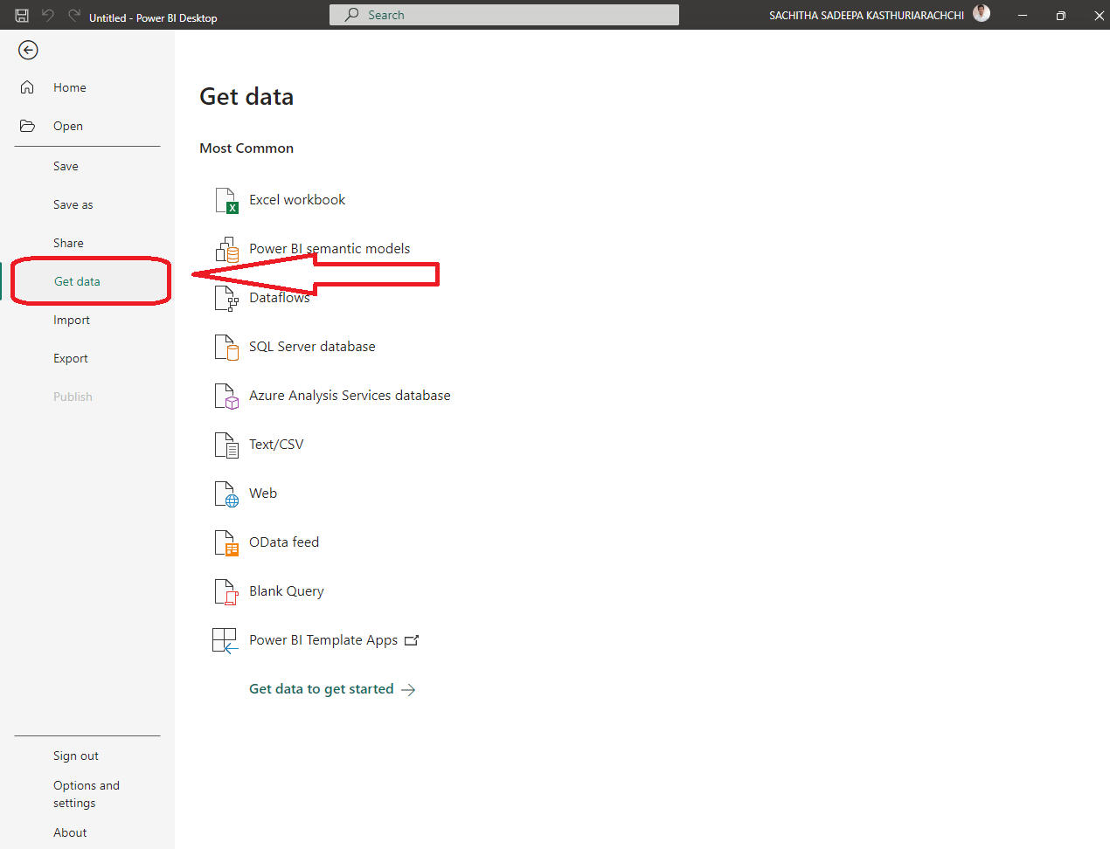

1. **Get Data** from the type of data source (Example **Excel work** boor or a **Text/CSV)**

1. For this example, I have chosen a **CSV file (File name: Pre_processed_Smart_bin_data.csv)**

***Note: This data set is already pre-processed using necessary data cleaning methods using python so there is no need of transforming this data set in power by itself.***

**Therefore, directly load the file for do the visualizations.**

1. Once you have loaded the **data pane section**, the data set will be visible in the **report view** with the file name appearing on it. And if you want to rename the file name you just right click on the file name and rename the file s you wish to rename.

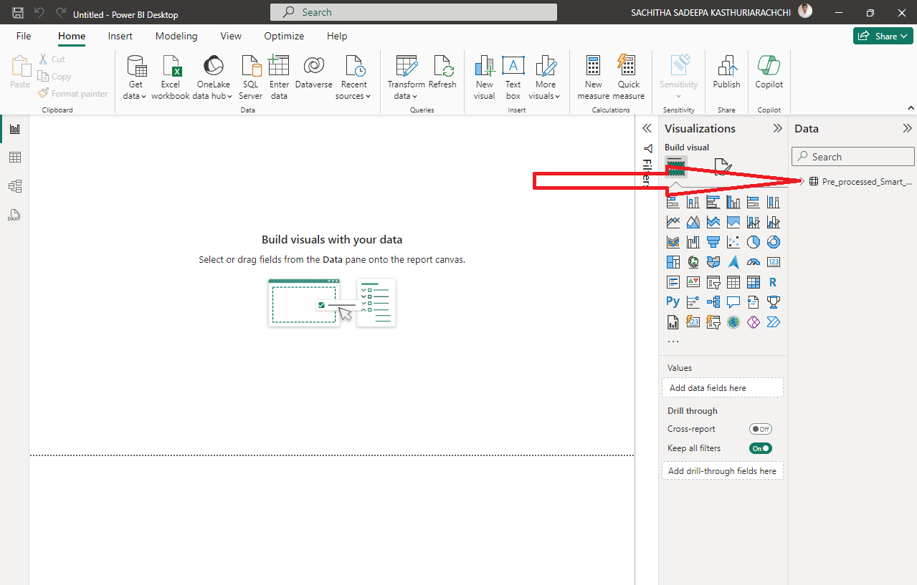

1. When you **click the file name** it will drop down the data columns in that file and from here on you are ready to do visualizations as required using appropriate **visualisations**

**Step 2: Create a chart in a report.**

1. After you connect data to build a report, you're ready to start exploring. When you find an interesting item, you can save it on the report canvas. You can pin the item to a dashboard to monitor the data for changes over time.

We can start by adding a column chart to the report in the editor to build a visualization of the data.

Some data items have a sigma **symbol (Σ)** next to the name. Power BI displays the sigma next to data that has **numeric values.**

1. Under **pre_processed_smart_bin_data**, select the **sensor_name** data item, and then select the **status_current_fill_level** item.

The below image shows the use of ribbon chart visualization.

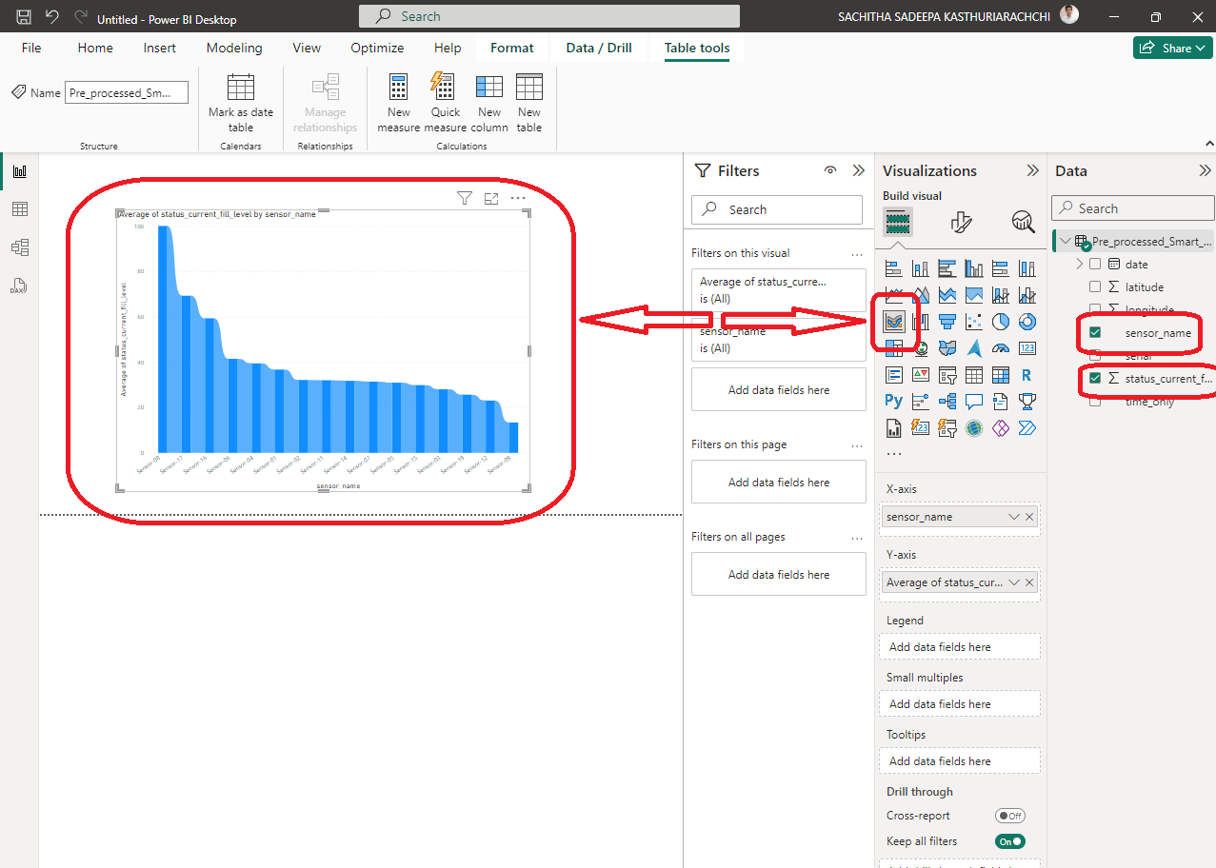

1. Let's try a different display of the selected data. And if you required more visuals, you can select the three doted ions in the bottom left of the visualization and **get** **more visuals.**

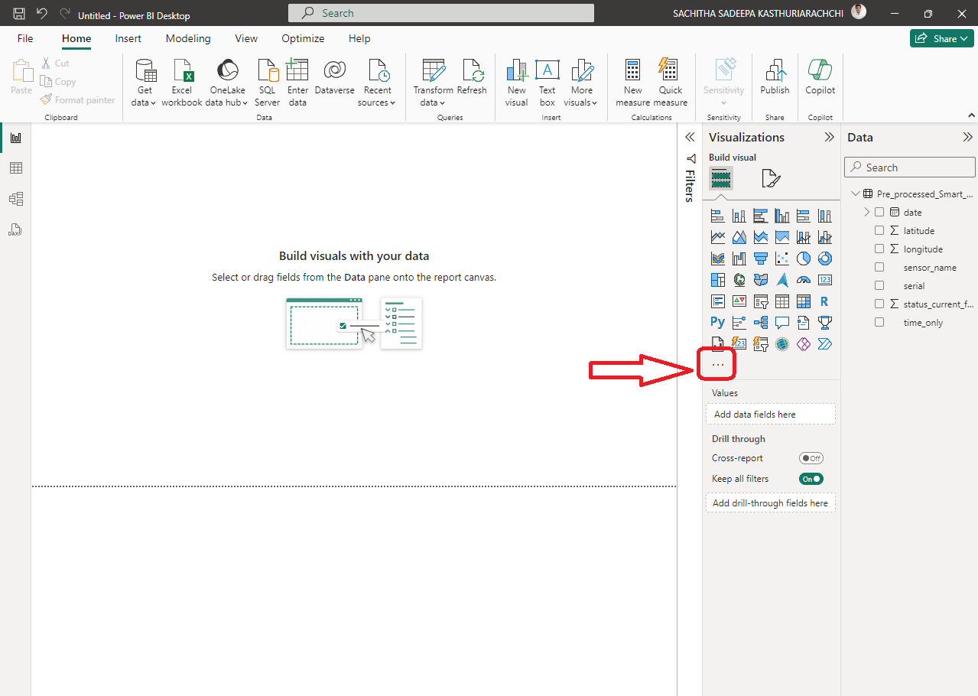

1. **Search for there required** visual you want from here.

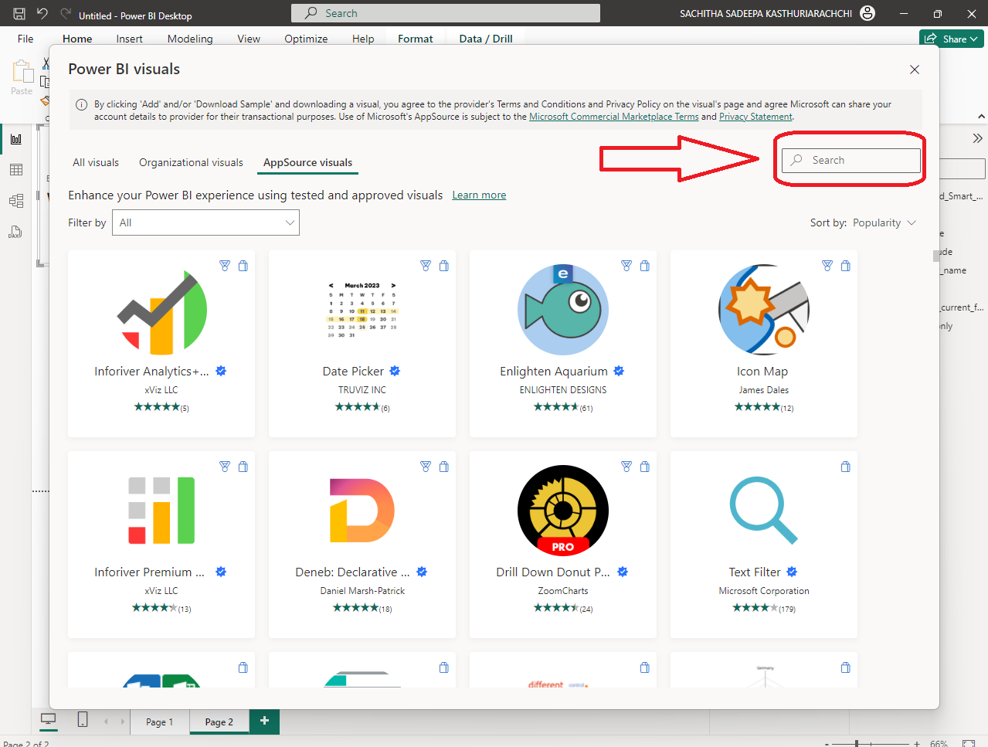

1. For this documentation I will be using the **Time Slicer,** and the below image shows how to load it and before loading it you Microsoft has provided a brief summary about the **Visual Capabilities**

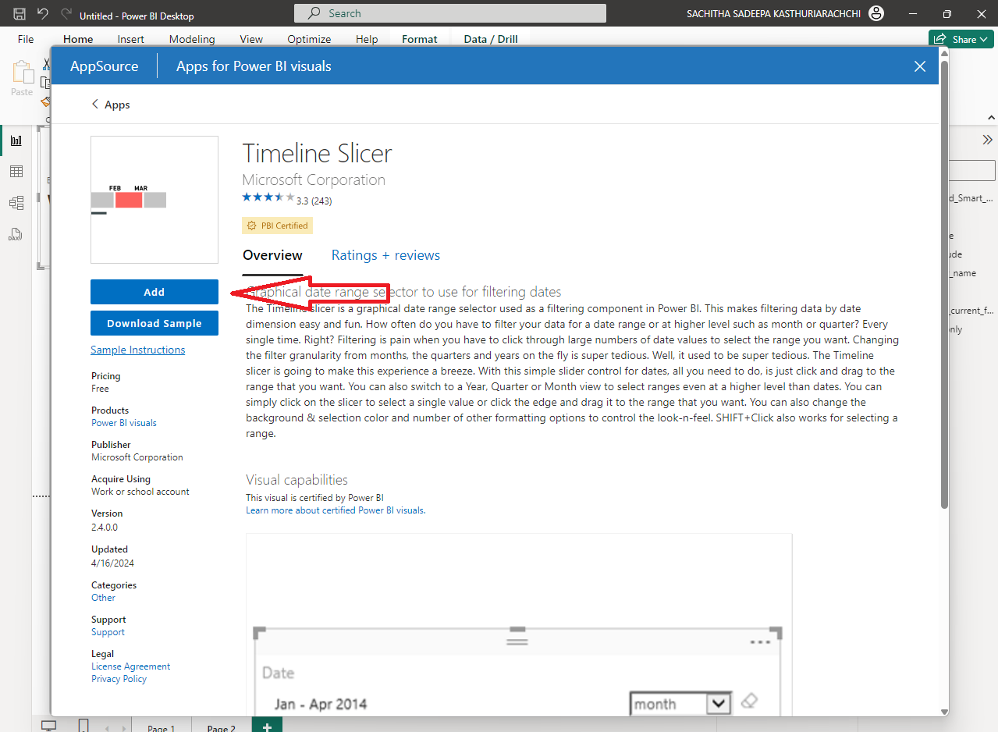

1. Under **the data set** select the **date** data item.

The below image shows the use of **Timeline Slicer** visualization.

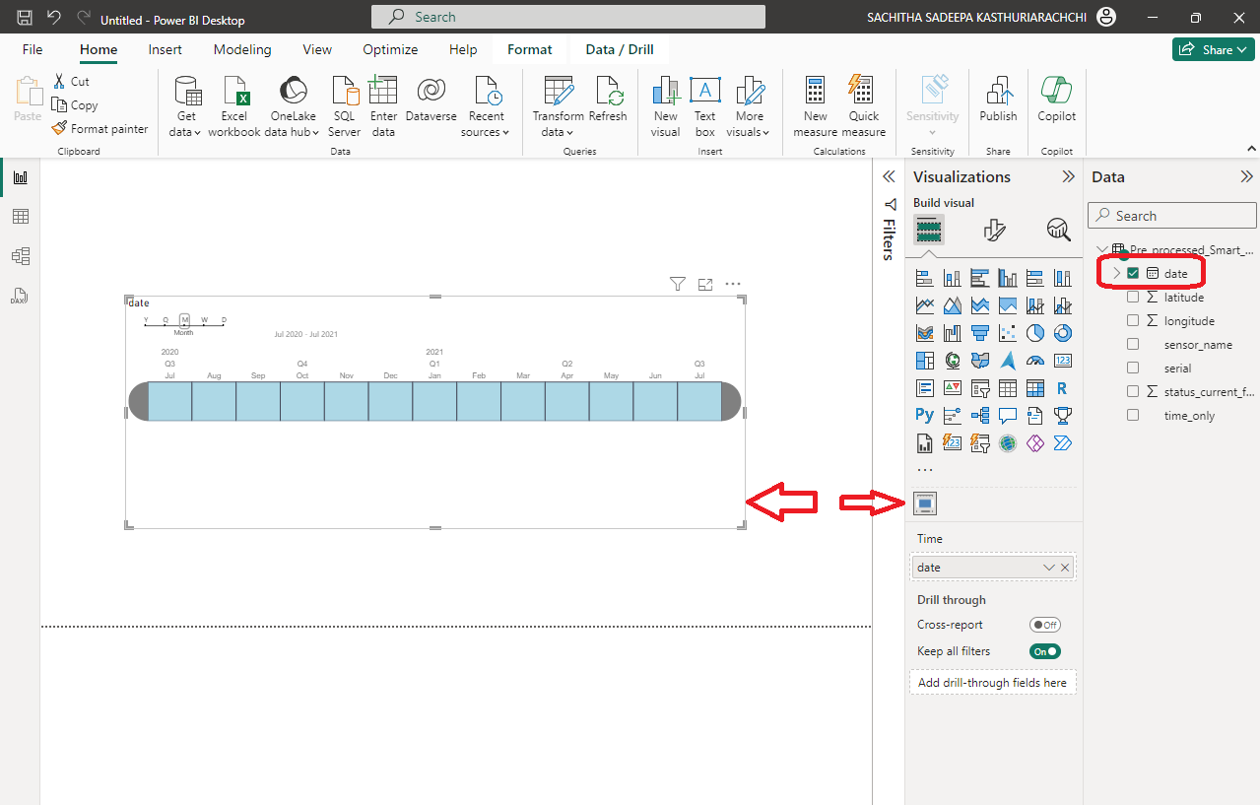

The timeline slicer shown in the image is a filtering control tool in Power BI that allows users to filter visualizations based on time dimensions. Here's how it's generally used:

* **Selecting Time Periods:** Users can select a specific period they are interested in by clicking and dragging across the dates. This is useful for focusing on data from a certain quarter, month, or even specific days.
* **Granularity:** At the top of the slicer, there are options to change the view to Year, Quarter, Month, or even Week. This allows for the granularity of the data to be adjusted according to the user's needs.
* **Dynamic Updating:** As you move the selection on the slicer, the visualizations that are linked to this slicer will dynamically update to reflect the data from the chosen time period.
* **Range Selection:** You can select a range of dates by clicking on the starting date and dragging to the ending date, which allows for the analysis of trends over that specific range.
* **Quick Filtering:** The arrows on either side of the timeline allow for quick filtering to the next or previous time period.
* **Button Controls:** The controls on the top right can be used to adjust the settings of the slicer or reset the selected range to its default state.

1. Under **the data set** select the **status_current_fill_level** data item.

The below image shows the use of **Guage tile** visualization.

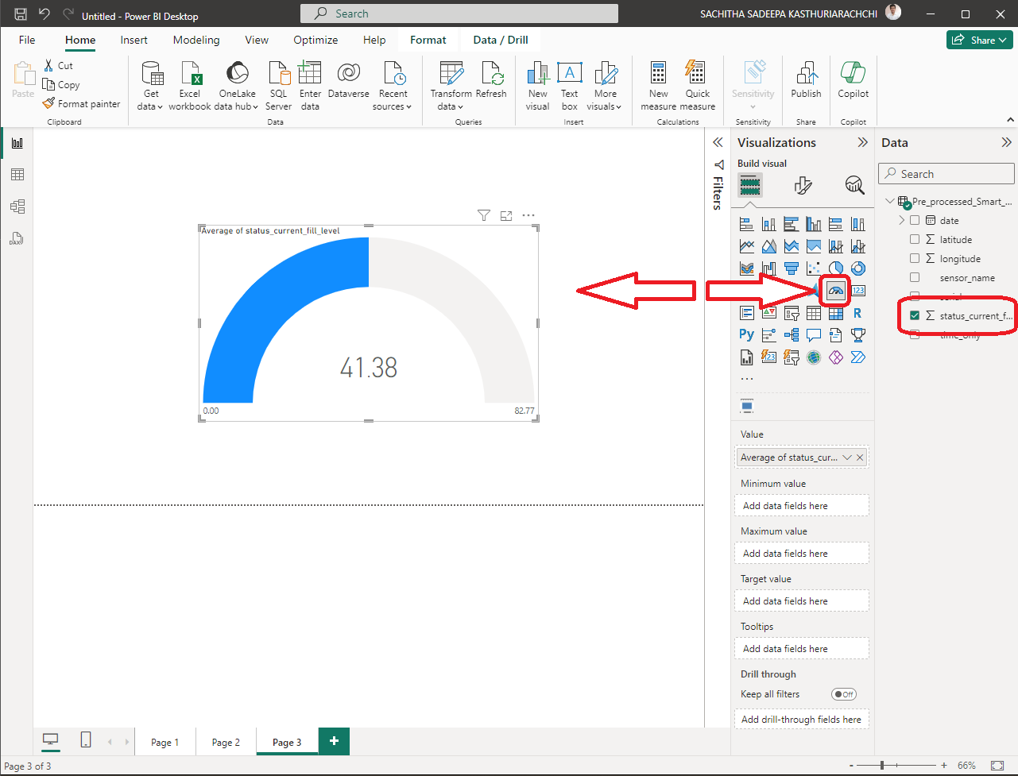

The image above shows a **gauge chart**, also known as a **speedometer chart**, which is used in Power BI to visually represent a key **performance indicator (KPI)**. Here's how to interpret it:

* **KPI Measurement:** The gauge chart is displaying the "Average of status_current_fill_level." This indicates that it is measuring the average fill level of a certain status, which could be the level of a tank, container, or any other measurable entity.
* **Value Display:** The prominent number in the middle of the gauge ("41.38") is the current value of the KPI being measured.
* Range Indication: The gauge has a range that starts at 0.00 and goes up to 82.77. These numbers typically represent the minimum and maximum values of the range, respectively.
* **Fill Level:** The shaded part of the gauge (the blue arc) indicates the actual value of the metric relative to the possible range. Here, it shows that the average fill level is approximately halfway to the maximum value.
* **Contextual Interpretation:** Depending on the context, a user can tell at a glance whether the current level is below, within, or above the expected range. Gauge charts are often used to show progress toward a goal or threshold.
* **Visual Impact:** The color (blue in this case) might also represent a status or urgency. Often, colors are used to indicate different states, such as red for critical levels, yellow for caution, and green for good or target levels.

The gauge chart is a common tool in dashboards as it provides a quick, visual representation of a single data point, allowing viewers to understand where the value stands immediately.

1. Under **the data set** select the **status_current_fill_level**, **Sensor_name** and **Date** data item.

The below image shows the use of **Line Chart tile** visualization.

The above line chart in Power BI, which is used to visualize trends over time across different categories. The specifics of this chart are as follows:

* **Multiple Series:** Each line represents a different "sensor_name," indicating there are multiple sensors (Sensor-01 to Sensor-08) for which the data is being plotted.
* **Data Aggregation:** The chart title "Sum of status_current_fill_level by Month and sensor_name" suggests that the data points represent the sum of the fill level for each sensor, aggregated by month.
* **X-Axis (Time Dimension):** The horizontal axis shows months of the year, indicating the time dimension over which the data is being visualized.
* **Y-Axis (Numeric Value):** The vertical axis shows the sum of the status_current_fill_level, which is likely a numeric measure, such as volume, percentage, or another unit indicative of a fill level.
* **Data Trends and Comparisons:** This type of visualization allows for easy comparison of trends over time between the different sensors. Viewers can quickly see which months had the highest or lowest aggregate fill levels.
* **Anomaly Detection:** The chart shows a significant spike for all sensors in July. This could indicate a special event, an error in data collection, or a real-world phenomenon affecting all sensors simultaneously.
* **Pattern Recognition:** Users can also observe patterns, such as cyclical trends, growth or decline trends, or any anomalies across different time periods.

In Power BI, such a line chart is interactive. Users can hover over data points to see exact values, click on legend items to filter the visual, and use other report elements to drill down or slice the data further. This interactive feature makes line charts useful for exploratory data analysis within the Power BI environment.

1. Under **data set**, select the **Latitude** and **Longitude** data item.

The below image shows the use of **Map tile** visualization.

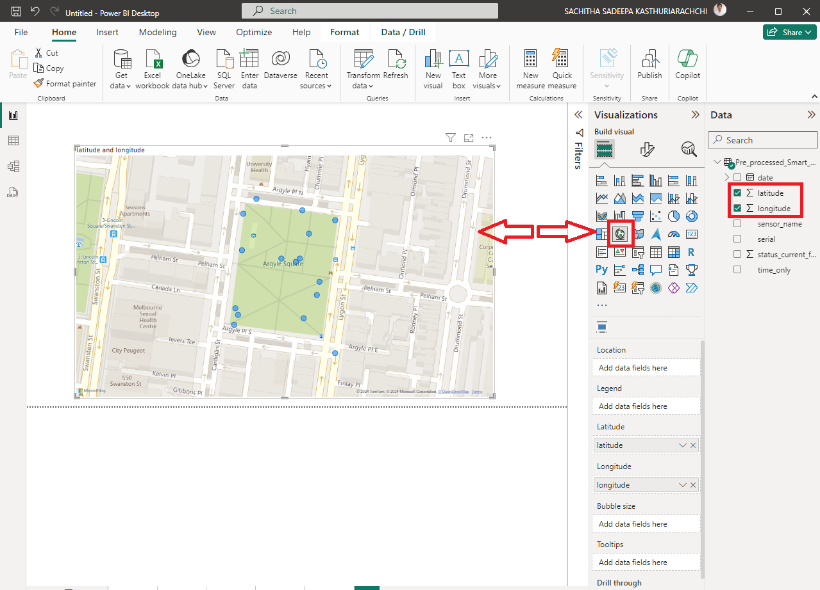

The map visualization above in Power BI known as a "**Map Tile**". This is how it's typically used:

* **Geospatial Analysis**: The primary use of a map tile in Power BI is to perform geospatial analysis by plotting data points based on their latitude and longitude coordinates. This allows users to see how data is distributed geographically.
* **Data Points:** The blue dots on the map represent individual data points that have been plotted according to their geographic coordinates. Each point can represent an event, a location of interest (like a store or a landmark), or any other location-based data.
* **Area Highlighting:** The shaded area, which in this case is Argyle Square, suggests a specific area of interest. This might be used to highlight a region where the data points are concentrated or to define an area for further analysis.
* **Interaction:** Users can interact with this map tile to get more details about each point or the highlighted area. For example, clicking on a dot might display additional information about that location, such as sales figures, population, or any other relevant data.
* **Integration with Other Data:** In Power BI, map tiles can be integrated with other visuals on a report. Selecting a point on the map could filter other visuals on the page to show related data.
* **Contextual Information:** The map provides contextual information that can be crucial for understanding the significance of the data. For example, proximity to certain landmarks or roads might explain patterns in the data.
* **Customization:** The map in Power BI can often be customized in terms of the type of map shown (road map, aerial view, etc.), the colour and size of the points, and the information presented when a point is selected.

This kind of visualization is very useful when location is a key aspect of the data being analysed, such as in logistics, retail analysis, urban planning, or environmental studies.

The example below provided is a blueprint for constructing an insightful dashboard tailored for a specific project, utilizing the guidelines mentioned. It demonstrates the capacity of Power BI to integrate diverse data visualizations, such as filters, gauges, histograms, time series, and maps, into a cohesive and interactive dashboard.

This dashboard not only captures real-time data updates and trends but also offers user engagement through its interactive components, allowing for an in-depth analysis of the project's key performance indicators.

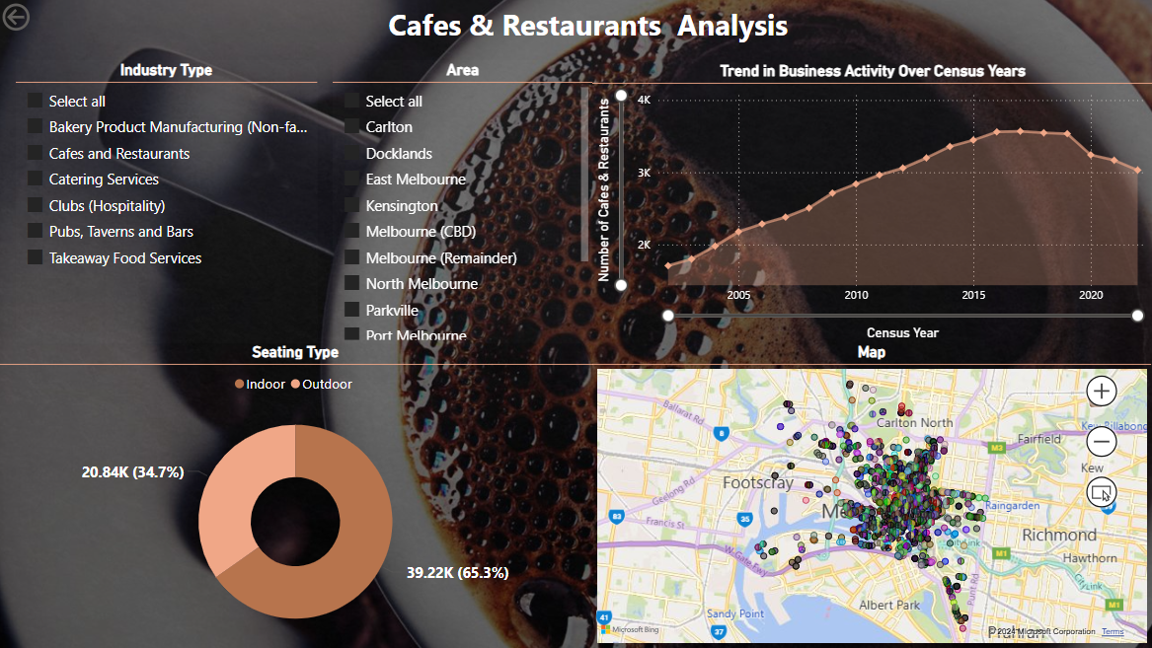

### **Benefits**

* **Integration and Connectivity:** Power BI offers robust integration capabilities, allowing it to connect with a wide array of data sources, including traditional databases, spreadsheets, cloud services, and even streaming data. This means that businesses can aggregate data from multiple sources to create a single, comprehensive view of information.
* **Ease of Use:** With its intuitive interface and drag-and-drop functionality, Power BI makes it simple for non-technical users to create complex reports and dashboards. The learning curve is relatively shallow compared to other data analytics tools, which democratizes data analysis and encourages a data-driven culture within organizations.
* **Real-Time Analytics:** Power BI provides real-time dashboard updates, which means businesses can respond promptly to changes as they happen. The ability to see up-to-date data helps organizations to be agile and make decisions quickly.
* **Customization and Interactivity:** Dashboards and reports are highly customizable, allowing users to tailor them to the specific needs of their audience. Interactivity is a key feature, with users able to drill down into visuals and charts to explore data layers and discover deeper insights.
* **Advanced Data Services Integration:** Power BI is part of the larger Azure data services family, and it integrates seamlessly with advanced tools like Azure Machine Learning, making it possible to incorporate predictive analytics into reports. It also has built-in AI capabilities to help identify patterns and trends.
* **Collaboration and Distribution:** The service facilitates collaboration, with features for sharing reports and dashboards within an organization. Power BI’s cloud service allows for easy distribution and access to analytics on any device, enhancing the ability to make decisions on the go.
* **Efficiency:** Significantly reduces the computational complexity compared to calculating distances on-the-fly during optimization.
* **Scalability:** Easily scales with increasing numbers of bins as only the matrix dimensions increase.
* **Accuracy:** Provides a reliable and consistent basis for route planning decisions.

### **Conclusion**

In conclusion, Power BI is a comprehensive business intelligence tool that offers scalability and efficiency. It enables businesses of all sizes to leverage data analytics for strategic decision-making. The ease with which it can be used and integrated into existing systems makes it a valuable asset for companies looking to enhance their data visualization and analytical capabilities. Power BI helps to transform raw data into compelling narratives and actionable insights, leading to better business outcomes.

## Author

Sachitha 2024.v1